VOWELS
- Vowels are produced with the smooth unobstructed air flow.
- The flow of air in the mouth can be adjusted by changing the position of the tongue, by rounding of the lips and by the degree of opening of the mouth.
- Typically all vowels are voiced.

- Vowels differ from consonants in two ways
- Vowels are articulated without any obstruction to the flow of air stream
- Vowels are different in their behaviour. Consonants occur in the syllable marginal position, whereas vowels occur in the syllable central position. (Kinyamagoha)
E.g. cat - /k æ t/

- Vowels qualities are determined by 4 factors.
- Height of the tongue (how high is the tongue raised without touching the tongue roof)
- The part of the tongue raised (blade, tip, back)
- Configuration of the lips (rounded or unrounded)
- The tension of the muscles in the oral tract. (tense & lax vowels)

Vowel chart

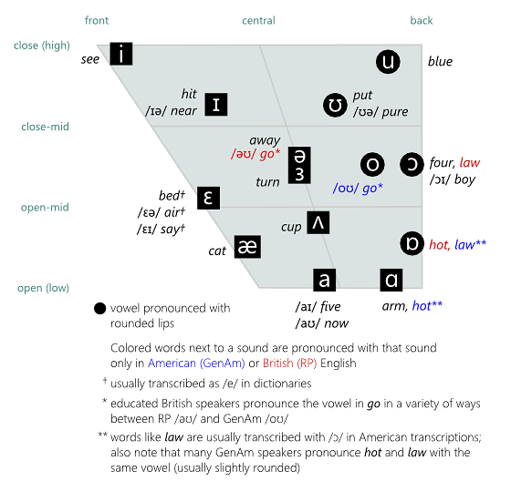

Classification of vowels
(Adapted from https://wac.colostate.edu/docs/books/sound/chapter4.pdf)
- Vowels can be classified as High, Mid and Low vowels according to the height of the tongue.
- Vowels can be classified as Front, Central and back vowels according to the backness of the tongue.
- Vowels can be classified as rounded and unrounded / spread / neutral vowels based on the configuration of the lips.
- Vowels can be classified as tense and lax vowels based on the tension of the muscle in the oral tract.

- High, mid and low vowels
High vowels are produced when the tongue body moves up leaving a very small space between the alveolar ridge and the tongue.
[i] as in seed
[I] as in hip
[u] as in glue
[ʊ] as in put

Low vowels are produced when the tongue body comes down.
[æ] as in apple
[a] as in five

When producing mid sounds the tongue neither raises nor comes down, rather it stays in the middle.
[ʌ] as in cup
[ə] as in about
[o] as in boat
[ɔ] as in bought
[e] as in bet
[ɛ] as in head

- Front, Central and back vowels

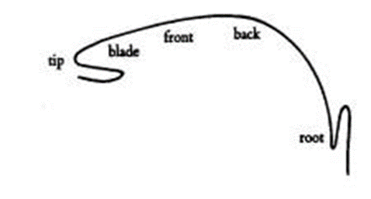
Front vowels are produced when the front part of the tongue is raised in the direction of the hard palate.
/i:/ as in beat
/e/ as in bet
/ɪ/ as in fist
/æ/ as in bat

Back vowels are produced when the back of the tongue is raised in the direction of the soft palate.
/uː/ as in food
/ʊ/ as in good.
/ɔ:/ as in caught
/ɑ:/ as in palm
/ɒ/ as in cot, pot and lot

Central vowels are intermediate between front and back vowels.
/ʌ/ as in cup
/ɜː/ as in Learn
/ə/ as in about

- Tense and lax vowels
Vowels that are produced with greater muscle tension in the articulators are ‘tense vowels’.
[i], [u], [e], [o], [ɔ], [ɑ] are tense vowels in English.
E.g. beat, bee [i]
boot, boo [u]
bait, bay [e]
boat, beau [o]
bought, paw [ɔ]
pot, spa [ɑ]

Vowels produced with less tension in the muscle of the articulators are called ‘Lax vowels’.
[I], [u], [ɛ], [æ], [ʌ] are lax vowels.
E.g. hit [I]
hood [u]
head [ɛ]
hat [æ]
hut [ʌ]

- Rounded and Unrounded vowels
When producing rounded vowels the lips become round in shape
[u], [ʊ], [o], [ɔ]

When producing unrounded vowels the lips are spread.
[i], [ɪ], [e], [ɛ], [æ], [ɑ], [ʌ], [ə]

Monopthongs, dipthongs and Tripthongs
(Adapted from https://www.scribd.com/document/364963086/EClinic-Phonetic-Symbols-pdf)
A vowel sound whose quality does not change over the duration of the vowel is called a “monophthong”. Monophthongs are also called "pure” vowels.
[i:] feet [fi:t] [i] fish [fiʃ]]
[u:] two [tu:] [u] book [buk]
[e] bed [bed] [ǝ] bird [bǝrd]
[æ] apple [æpl] [ʌ] sun [sʌn]
[ɔ] ball [bɔl] [ɑ] mama [m'ɑmɑ]
[ǝ] alive [ǝl'aiv]

A vowel sound that glides from one quality to another is called a diphthong.
[ai] eye [ai]
[au] mouse [maus]
[ɔi] toy [tɔi]
[ju] you [ju]
[ei] cake [keik]
[ou] go [gou]

A vowel sound that glides successively through three qualities is a triphthong.
/aʊə/ hour
/faɪə/ fire
/pleɪə/ Player

Reference
Kinyamagoha, Y. https://www.academia.edu/8170587/3._The_phonology_of_English_vowels_an_introduction

